# [**‘Law & Order: Organized Crime’: Matt Olmstead Exits As Showrunner Of ‘SVU’ Spinoff Starring Christopher Meloni**](https://deadline.com/2020/10/law-order-organized-crime-matt-olmstead-exits-showrunner-svu-spinoff-christopher-meloni-star-1234590295/)



By [Nellie Andreeva](https://deadline.com/author/nellie/)

### [**Nellie Andreeva**](https://deadline.com/author/nellie/)

*Co-Editor-in-Chief, TV*

[@DeadlineNellie](https://twitter.com/DeadlineNellie)

October 2, 2020 9:20am

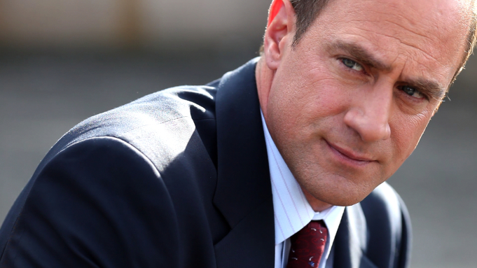

NBC

There is a change at the helm of the upcoming [NBC](https://deadline.com/tag/nbc/) series [*Law & Order: Organized Crime*](https://deadline.com/tag/law-order-organized-crime/), starring [Christopher Meloni](https://deadline.com/tag/christopher-meloni/) as his *Law & Order: SVU* character Elliot Stabler. [Matt Olmstead](https://deadline.com/tag/matt-olmstead/) has stepped down as writer-showrunner. There is no immediate replacement.

There was a hint at the behind-the-scene change when Wolf Entertainment and Universal TV [recently set up production start dates](https://deadline.com/2020/09/law-order-start-production-new-york-dick-wolf-chicago-fire-chicago-pd-chicago-med-fbi-fbi-most-wanted-1234576263/#:~:text=11%2C%20with%20Law%20%26%20Order%3A,venerable%20drama%20premiere%20on%20Sept.) for all of their joint series but *Law & Order: Organized Crime*, initially part of NBC’s fall 2020 fall schedule.

The *SVU* spinoff drama revolves around the NYPD organized crime unit led by Stabler.

According to sources, a decision was made to take extra time crafting the new series that reintroduces a beloved character alongside the original *Law & Order: SVU* series that tackles the NYPD. There has been extra scrutiny on portraying police work on TV following the death of George Floyd and the national unrest it sparked.

Switching showrunners early on is not uncommon for Wolf series. *FBI* went through multiple showrunner changes before and right after the series’ premiere on CBS. It went on to become the most watched new series of the season and is now headed into Season 3 after successfully launching a spinoff.

Olmstead, whose exit was first reported by THR, is a Wolf Entertainment veteran as co-creator and original showrunner of *Chicago P.D.* He will continue to develop under his overall deal with Universal TV, part of Universal Studio Group.

*Law & Order: Organized Crime* is executive produced by Wolf, Arthur W. Forney, Peter Jankowski, Fred Berner and Terry Miller.